

National Conference Subsidy Application Form

Habitat for Humanity Canada is offering affiliates the opportunity to receive a $500 subsidy to attend the National Conference and AGM in May. To qualify, your affiliate must be located **outside of** **Ontario**. Please note that later in the year affiliates outside of Ontario will also be given the opportunity to apply for a $500 subsidy to attend the Leadership Summit in November. **Please note that if you attend both, you will still only receive one $500 subsidy**. This subsidy can be used to help off-set travel costs.

**Affiliate Name:** Click here to enter text.

**Names of Affiliate Members Attending:** Click here to enter text.

National Conference and Annual General Meeting

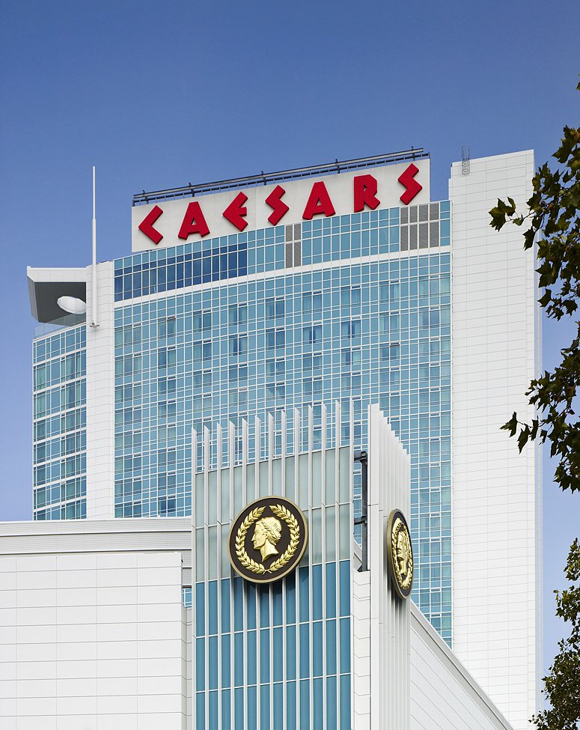*Wednesday, May 8 to Friday, May 10, 2024  
(ED CEO Orientation May 7)*

**Caesars Windsor Hotel and Casino**377 Riverside Drive East Windsor, ON N9A 7H7

Registration opens March 4.

Please submit this application form to Deanna Miller, Senior Manager, National Conferences and Events via email, [dmiller@habitat.ca](mailto:dmiller@habitat.ca), by Monday, April 22 - if attending the National Conference and AGM.

For questions or more information please contact Deanna Miller, [dmiller@habitat.ca](mailto:dmiller@habitat.ca) or

905-407-3128.

*Please Note: Subsidies will be granted once registration for your event of choice is complete and paid for in full. This is per affiliate, not per person in attendance.*