National Conference Subsidy Application Form
Habitat for Humanity Canada is offering affiliates the opportunity to receive a $500 subsidy to attend the National Conference and AGM in May. To qualify, your affiliate must be located outside of Manitoba. Please note that later in the year affiliates outside of Ontario will be given the opportunity to apply for a $500 subsidy to attend the Leadership Summit in November. Please note that if you attend both, you will still only receive one $500 subsidy. This subsidy can be used to help off-set travel costs.

Affiliate Name: Click here to enter text.
Event Attending: Choose an item.

Names of Affiliate Members Attending: Click here to enter text.
National Conference and Annual General Meeting
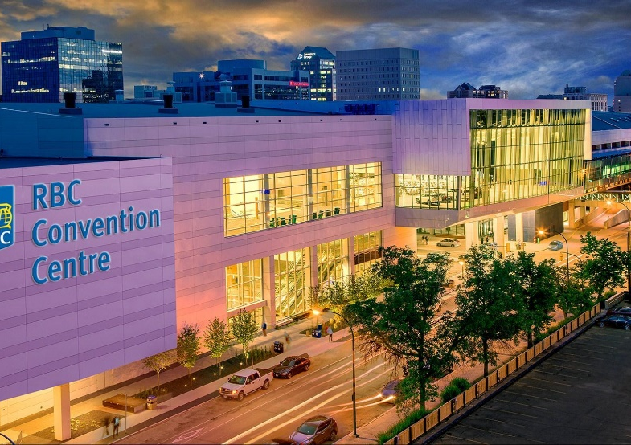
Wednesday, May 10 to Friday, May 12, 2023 (ED CEO Orientation May 9)
Delta Hotels by Marriott Winnipeg
350 St Mary Ave, Winnipeg, MB R3C 3J2
RBC Convention Centre Winnipeg
375 York Ave, Winnipeg, MB R3C 3J3
Registration opens March 6.

Please submit this application form to Deanna Miller, Senior Manager, National Conferences and Events via email, dmiller@habitat.ca, by Monday, April 17 - if attending the National Conference and AGM.

For questions or more information please contact Deanna Miller, dmiller@habitat.ca or
905-407-3128.
Please Note: Subsidies will be granted once registration for your event of choice is complete and paid for in full. This is per affiliate, not per person in attendance.

